

Troyka Med Inc.
MRI LED Monitor 32’’

User Manual

Introduction
The MRI LED Monitor is used to present visual stimulus within the MR environment. It is an add-on to the FMRI Hardware System. The LED monitor uses a standard HDMI signal input, convert it to fiberoptik and transfer the optical signal to the LED monitor. So, can be connected to any desired computer.
This User Manuel covers all important information regarding operation of the LED monitor.
Our hardware team strongly suggests full review of this Manuel prior to operation of the LED for two reasons: (1) to ensure safe operation of the LED in MRI environment.

The Troyka Med 32’’ LED Monitor complies with the EU regulations for active medical devises, Medical Device Directive 93/42/EEC, classified as a medical Device Class I product.
Contents

1. Safety Information

1.1 General Safety Information and intended use
The LED must only be operated by personnel property trained in MR Safety.
The intended use for the LED is to present visual stimuli within the MR environment. It’s important that the use of the screen is kept within the MR environment where the temperature and humidity is kept on a stable level. Any use other than described is not permitted.
The LED must only be operated by personnel properly trained in identifying interference problems such as artifacts, streaks and distortions in image data. It is required that as personnel handling the LED are familiar with the safety instructions given in the Manuel and other documentation provided to ensure safe operation of the LED and associated equipment.
When connecting the LED to a PC, it must be verified that the PC complies with IEC/UL 60950-1. This will ensure safe operation. Note: must standard PCs sold by established vendors comply with this standard.

1.2 Electrical Safety
 | Warning  Any electromagnetic signal can cause interference on the LED or data collection within the MRI suite. In order to minimize such interference, all ferrous or RF signal emitting devises should be placed far from the scanner, and not come within 200 Gauss (20 mT) of the scanner.
Warning
The introduction of electromagnetic equipment (such as is introduces with the Shielded Interface Unit) can cause interference in the function of the MR scanner or in the data collected. It may also affect the function of the LED, other medical electronic equipment and systems within the MR suite.
Warning
Contain electric components in the device require several hundred volts to operate properly. In order to prevent potentially lethal electric shock it is essential to disconnect the device from its power source during installation, and prior to servicing or repair. Some capacitors will remain charged with dangerous voltage levels even after the power is off. In order to prevent any possible electric shock, please wait several minutes for all capacitors to become completely discharged before proceeding.

Do not operate the device near the water, where it can become moist, or near excessive heat. Operation under such conditions could result in failure of the LED, possible electric shock, or fire. Don’t handle the power cable with wet hands. High voltages present could cause lethal electric shock.

Should any foreign substances enter the device such as liquid, metal chips or dust, immediately turn off power to the LED. Under no circumstances shall tools or foreign objects be inserted into the device, as this could result in failure of the device, electric shock or fire.

If smoke, noxious odors or unusual noise should come from the device, immediately turn off power to the LED. If the device is incapable of displaying a picture after it has been turned on, turn it off and do not attempt to operate.

Do not damage the power cable of the device. Do not attempt to modify the power cable should it malfunction. Should the power cable become damaged or frayed, it must be replaced. Do not attempt to use an alternative power cable. Use only what was supplied with the LED.

If transportation of the LED is necessary, switch off the power, disconnect all power and signal cables and then move it to its new position with care.
To disconnect the equipment from the power supply, the power cord must first be removed from the power outlet.

Do not attempt to remove the back panel of the LCD, as this presents an electric shock hazard. Any and all service should be conducted by qualified service personnel only.

Do not operate the LED if any cables are damaged.

Switch off and unplug the LED if it not be in use for 3 days or more.
If this equipment is modified, appropriate inspection and testing must be conducted to ensure continued safe use of equipment.
Warning
If the MRI-LED-Monitor is modified, appropriate inspection and testing must be conducted to ensure continued safe use of the LED.

Warning
To avoid risk of electric shock, this equipment must only be connected to supply mains with protective earth.

1.3. Safety Precautions and Maintenance
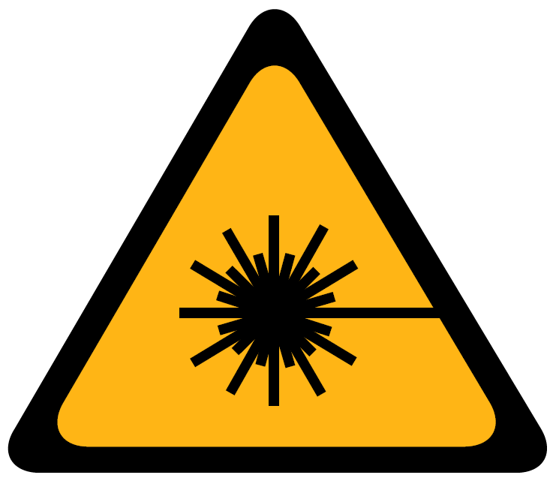 | Caution  Eye injury can be caused by the light beam of the Fiber Transmitter.  Never look directly into the optical connectors or fiber optic cables.
Warning
Do not allow liquid near the LED. If liquid accidentally comes in contact with the LED Monitor, turn the equipment off and unplug the mains immediately and take it to the Troyka Med team for assessment and/or repair.

Handle the LED very carefully; do not subject it to excessive vibrations or movement of any kind.
Do not obstruct or covert the LED with any type of material objects.

Clean the equipment only when it is switched off and unplugged. Use only a slightly damp cloth to clean the LED, do not use alcohol or ammonia-based products.

Do not place objects on top of the display cabinet or the shielded interface unit, which could fall into vents or which could cover them and prevent proper cooling of the electronics.

Do not expose the display to rain or excessive moisture to prevent shock or permanent damage.

Consult a service technician if the display does not operate normally when the operation instructions are followed.

Warning
For a small percentage of the population, viewing certain types of video that contain flashing patterns of light may trigger epileptic seizures.
The following users are cautioned to consult an physician before using the LED:
- children under 5 years,
- anyone with a history of epilepsy or a family history of epilepsy,
- anyone who has ever experienced epileptic seizures or sensory disturbances triggered by flashing effects.

Warning
Self-heating of cables due to improper cable routing! Injury to equipment and/or operating personnel.
- Cables should not be looped crossed.

Caution
The LCD system gets hot during operation! Burn hazard
- Allow the system to cool down in 5min after operation, before touching it.

Table 1: Electrical safety signs and descriptions

1.4. Product Marking and Labeling
Consult Accompanying Documentation
This is general symbol used to encourage users to get familiar with the accompanying documentation and safety precautions before using the system.

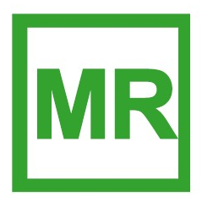 | MR Safe  An item considered safe for use anywhere inside the magnet room.  - Feberoptic Cables  - Cable Protection Spiral
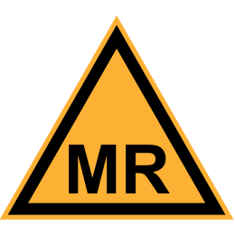 | MR Conditional  An item that has been demonstrated to pose no known hazards in a specified MR environment with specified conditions of use.  This marking applies to:  - LED  - Shielded Interface Unit (SIU)  - 25 Pin Power cable for LED  - 25 Pin LPF  - LED Stand  See installation guide for each product for safe operating conditions
 | MR Unsafe  An item that is known to pose hazards in all MR environments and must not be brought into the MR suite.  This marketing applies to:  - Fiber transmitter  - Shielded Interface Unit (SIU)  - LPF  - Power Cable
Power ON
The power on symbol, appearing on one end of a toggle switch indicates that the control places the equipment into a fully powered state.
 | Power OFF  The power off symbol on a toggle switch indicates that using the control will disconnect power to the device.
Table 2: Product marking, labeling and descriptions.

2. General Information

2.1 Inspection of Delivered Goods
Each of LED monitors has been thoroughly tested prior to deliver and is ready for immediate use. Upon receipt, please report any transportation damage or missing accessories immediately. Troyka Med can only accept liability for such damage if it is claimed prior to initial operation. In case of transportation damage, please contact the Troyka Med service department. For faster support please have ready all shipment details LED seral number and damage description. It is recommended to keep and store the original crate/box used to ship the LED for all future transportation needs.

2.2 Power Connection Information
The LED operates on the line voltages 90-250V AC and 50/60 Hz. It is not necessary to double check line voltages or change any fuses. The equipment should be near the power outlet in the MR suite and the outlet should be easily accessible.
Stabilizing circuits ensures satisfactory performance within supply variations specified. If the supply voltage in your location is not 90-250V AC, please consult your Troyka Med Sales or Service office.
Always use the power supply card supplied in the original shipping carton.
If the enclosed power card could not be used due to a different standard in your country, use a power card that conforms to the fallowing regional standards:
United States (UL) | United Kingdom (BASEC/BS)
Germany (VDE) | Switzerland (SEV)
Canada (CSA) | Japan (MITI)

In other regions, please use an AC power card that complies with the country’s safety regulations.
In order to prevent electrical hazard, the cord set must use a three-core cable of at least 6A/0.75mm², and have an earth ground contact on both the free socket and the plug. If the main cord is damaged, use only an original replacement cable.
Warning
The fuse holder for the main fuse is integrated in the power inlet in the shielded interface Unit (SIU). For continued protection against risk of fire, only replace fuse with same type, characteristics and voltage rating. Disconnect power before changing the main fuse.

Note: Incorrect cable connections may result in irregular LED function, damage to the LED quality/components and may shorten the life of the unit.

3. System Overview and Installation Guide

3.1 System overview
The LED monitor consists of four components:
- Monitor: a powerful and flexible solution which utilizes LED backlight technology to present visual stimuli in the MR room.
- Shielded Interface Unit (SIU): Shielded enclosure contains the Power supply and related interface circuits for integration of the monitor in MRI suite.
- Fiber Transmitter: Transmitting video from a computer to into the optical signal, which eliminates electrical interference brought into the scanner room.
- LED Stand: Stand for the monitor, which is produced from non-ferromagnetic materials and is MRI safe.

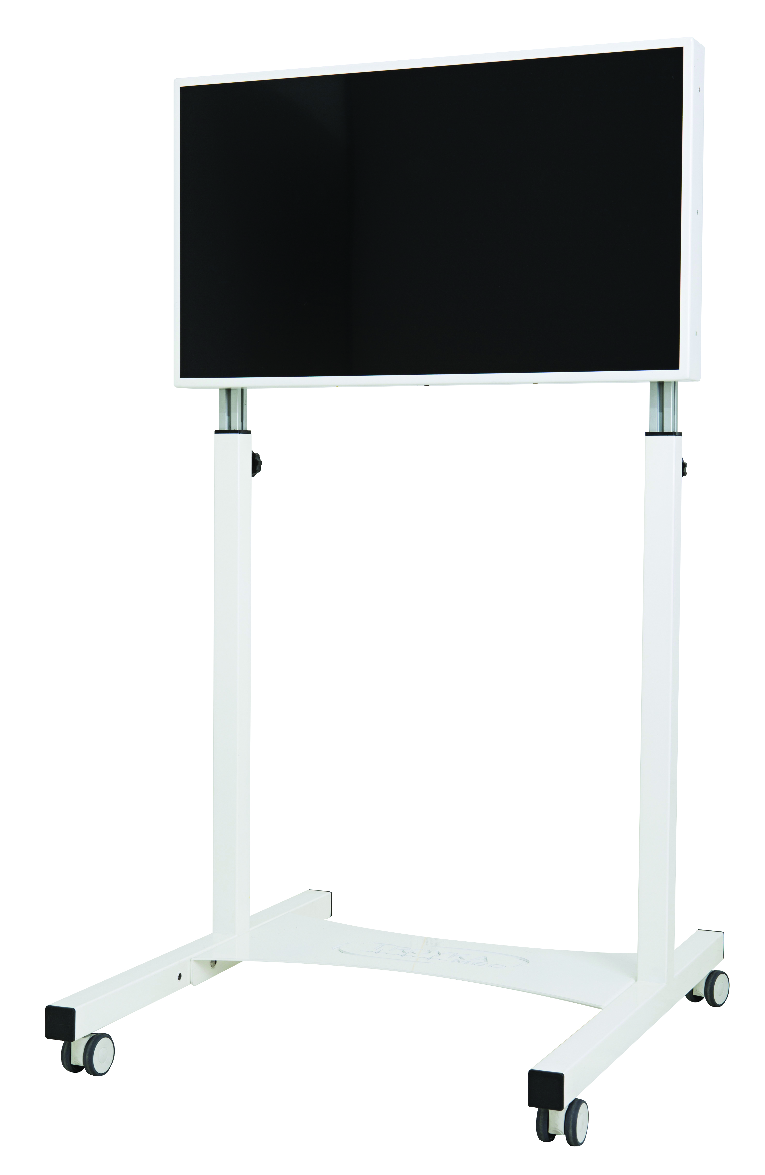

Figure 1: Overview of the signal path and set-up of the MRI LED Monitor.

3.2 Installation

3.2.1. Parts Included
1 |  | MRI-LED Monitor  Presentation of visual stimuli and video materials inside the MR room    To avoid any accidents, the MRI-LED Monitor should be kept no closer than 1.5 Tesla field from the magnet. The legs length will prevent the screen getting closer than 1.5T to a 3T scanner.
2 | 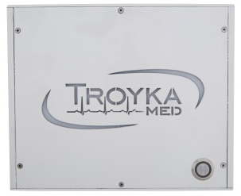 | Shielded Interface Unit (SIU)  Shielded enclosure for the Power Supply Unit  The SIU contains ferromagnetic materials and must be kept at the safe distance from the MR scanner (outside the 40mT (400 Gauss) line).
3 | 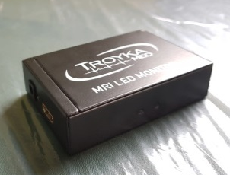 | HDMI – Fiber Transmitter  Converts video signal into optical signal for transmission to MR room.  Contains ferromagnetic materials, keep out of the Magnet Room  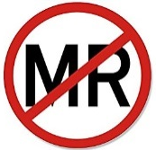
4 | 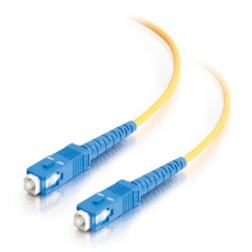 | Fiber Cable    Connection between the HDMI – Fiber Transmitter and the MRI-monitor through an available waveguide.  This cable is fragile  Maximum bending radius: 10cm
5 | 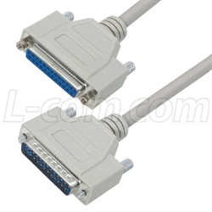 | 25 Pin Cable (7m)  Transmit the power from the SIU to MRI-Monitor. This cable Connecting SIU to LPF at the penetration panel in cabinet room. Similar cable is used to connect LPF inside MRI suite to MRI-LED Monitor.  The 25 pin cable contains ferromagnetic materials and must be kept at the safe distance from the MR scanner (outside the 40mT (400 Gauss) line).
6 |  | 25 Pin Cable (3m)  Transmit the power from the SIU to MRI-Monitor. This cable Connecting SIU to LPF at the penetration panel in cabinet room. Similar cable is used to connect LPF inside MRI suite to MRI-LED Monitor.  The 25 pin cable contains ferromagnetic materials and must be kept at the safe distance from the MR scanner (outside the 40mT (400 Gauss) line).
7 | 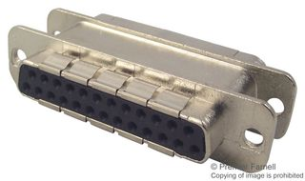 | 25 Pin-LPF  The LPF is mounted to the penetration panel. And filter the power signal between the SIU and MRI-LED Monitor.
8 | 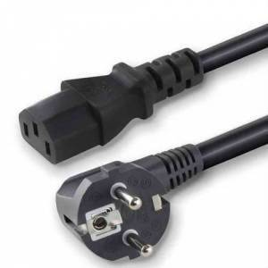 | Power Cable  For the SIU. The power cable delivered with your system may very depending on your type of mains outlet and may come in dual configuration.  Power Cable contains ferromagnetic materials and must be kept at the safe distance from the MR scanner (outside the 40mT (400 Gauss) line).
9 | 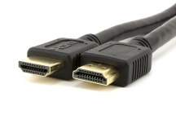 | HDMI Cable  Connection of the Fiber Transmitter with the stimulus presentation PC.  Contains ferromagnetic materials, keep out of the Magnet Room
10 |  | Cable Protection Spiral  For use to boundel 25 pin power cable and fiberoptik cable with cable protection purposes.  This item I produced from plastic so considered safe for use anywhere inside the magnet room.  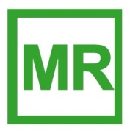
Table 3: Parts Included and descriptions
The stand consisting of the fallowing items:
1 | 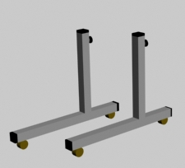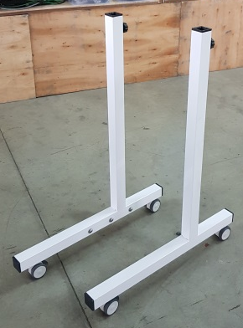 | 2 | 2x L shape foot with wheel with brakes
2 |  | 1 | 1 x Lower vertical stabilizer
3 | 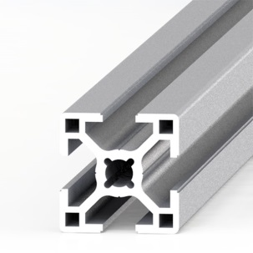 | 2 | 2 x Sigma profile for telescopic lags
4 | 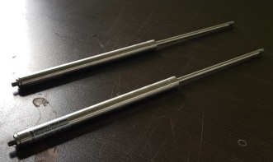 | 2 | 2 x Damper for telescopic legs
5 |  | 1 | 1 x Back caver with logo
6 |  | 12 | M8x16 Allen screw with washer
7 |  | 6 | M4x16 Allen screw
8 |  | 2 | Connection element for vertical stabilizer
9 |  | 2 | Sigma profile top cover
10 | 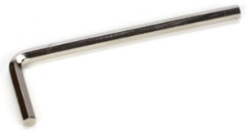 | 1 | Allen tool (5mm)
Table 4: List of stand components

3.2.2. LCD Stand Assembly Instruction
Warning
The LED stand should be assembled outside the MR suite. The stand should not to be brought inside until the LED screen in attached.
The assembly of the LED stand is delivered into three steps:
Step 1:
- The L shape Leg (Table 4-1) is delivered with three M8x16 Allen screw with washer on each.
- Unscrew the screws from the L shaped leds.
- Use the lower stabilizer (Table 4-2) to connect two L shape legs together as shown on Fig. 2. Use Allen given on Table 4 – 10.
Step 2:
-Use two telescopic sigma legs (Table 4-3) and 6 M8x16 allen screws (Table 4-6) to connect legs to the monitor as is described on Fig. 3.
- Use back cover (Table 4-5) and M4x16 Allen screw (Table 4-7) to connect it to the back side of the monitor (Fig. 4).
- Use two dampers (Table 4-4) to screw them to the lower end of the sigma profile (Table 4-3)(Fig.
Step 3:
-Unscrew the tightening wheel on both legs and gently lower the telescopic legs through the L shaped Legs. The tightening bolt must be placed through the telescopic legs rail.
- The MRI-Monitor has the option to adjust the height of LED screen above the floor. To do this, loose the tightening wheel while holding the screen. Gently lower or raise the screen. Tighten the both of the tightening wheels to ensure that it stays in desired position.
- Use a water balance tool to adjust final horizontal position of the monitor.

Warning
Crush hazard. Keep hands away from moving telescopic legs, when lowering the LED.

3.2.3. System Installation Instructions
Warning
The LED should be assembled outside the MR suite. Only MR conditional parts should be brought into the MRI suit.

Operator Room
- Connect one end of the HDMI cable (Table 3-9) to the desired PC-HDMI port and the second end to the fiber transmitter (Table 3-3).
- Connect the fiber cable (Table 3-4) to the fiber Transmitter and feed the fiber through the waveguide into the MR suite.
- Connect the 5 V DC adapter to the power inlet of the transmitter.
LPF Installation
The LPF installation could be done in three different methods, any of this methow could be choose.
Method 1
Most of the MRI scanner manufacturers have 25 pin LPF filter on the penetration panel to be used for external MRI equipment connection. In the case your MRI scanner has an available 25 pin filter on it, use it.
Method 2
Some MRI scanner manufacturers have a hose for 25 pin LPF installations. In this case unscrew the cover of the hose any install the filter. The shaft of the filter must be kept in MRI room. The male side of the filter must be connecter through the hose from MRI room to cabinet room.
Method 3
This method should be applied in the case there is neither no available filter nor available hose for filter installation. In this case:
-Choose most suitable removable plate on the penetration panel.
-Remove the plate from the panel.
-Tightly, close the hole with caper tape so that during your work RF noise don’t penetrate through the hole and effect the scanner image quality during your work.
- Contact Troyka Med service team to get exact droving of filter hose.
- Use any available CNC method to open a hose for the filter on it.
- Place the filter on the plate as was described in method 2.
- Remove the copper tape prove the penetration panel and install the plate with the filter back.
Cabinet Room
-The desired location for the SIU should be selected. The distance from SIU to the 25 pin LPF at the penetration panel must be les then 3 m. The SIU must be near to the AC power outlet.
-Once the final localization for the installation has been selected, wall mount step must be done.
-The SIU has two wallmont fixture on the back side. The male part should be take off and fixed to the wall as is described on fig. 5
-Then the SIU must be placed through the male wallmount fixture for final localization.
-Use 3m length 25 pin cable (Table3-6) to connect the SIU to the LPF.
-Use power cable (Table 3-8) to connect SIU to AC power outlet.
Magnet Room
-The LED monitor is normally located at the back of the scanner or at the side of the patient bed. This should be kept in mind when cabling is done.
-Connect the 25 pin power cable (Table 3-5) between the LED Monitor and the LPF. Start with connecting the LPF end first.
-Connect the fiber cable to the fiber SC fiber connector at the back of the monitor. The fiber has double core, one for main use and the second as a spare.
Note: The cables have markers on the ends. Make sure that you connecting the same core to the monitor and fiber transmitter in operation room.
Caution

Don’t move the LED by dragging or pulling the power cable. This could results in multifunction and damaging the system.

4. Maintenance and Disposal

4.1 Cleaning Information
Dust and other matter that collect on the LED may eventually degrade picture quality. Such matter should be removed from the top of the LED with a damp cloth.
Warning

Unplug all power connections before cleaning.

4.1.1. Screen Surface
Dampen (do not saturate) a clean, lint-free cloth with environmentally friendly glass cleaner. The cleaner contains spirit as active substance (up to 98%) and tensides, which can be biologically recycled. Cline the monitor screen using circular motions with the cloth to avoid streams. Remove fingerprints, grease, dirt, and dust. Carefully dry the screen with a second, lint free cloth.

4.1.2. LED Stand and wires
Use a cloth with disinfectant to clean the stand and wires. Remove fingerprints, dirt, grease and dust. Do not use any oil or grease on the mechanical parts or wheels.

4.1.3. Correct Disposal of the LED
To prevent possible harm to the environment due to uncontrolled waste disposal, please separate this product from other types of waste and recycle it responsibly at the end of its working life.
Users should contact their local government office for details regarding where and how the LED for be safely recycled.
Alternatively, the product can be returned to Troyka Med for appropriate disposal.

5. Technical Specifications
LED Monitor
Display type | TFT active matrix liquid crystal panel
Screen Diagonal | 32"
Active area | 698,4 mm(H) x 392.85 mm(V)
Pixels | 1920 x 1080
Pixel Arrangement | R, G, B vertical stripe
Display Colors | 16,7 M
Surface Luminance | 350 c/M2 typ
Contrast Ratio | 50000:1 typ
Input Refresh Rate | 60 Hz
Display Refresh Rate | 120 Hz
Backlight | LED
Response Time | 8 ms
Color Gamut | 72%
H-Scanning Frequency: | 30 ~ 81 kHz
Maximum Pixel Frequency: | 148,5 MHz
V-Scanning Frequency: | 48 ~ 75 HZ
Optical Input | SC-Connector
Fiber Transmitter
Input Signal | HDMI
Electrical Connector | HDMI
Optical Connector | SC
Max Data Transfer Rate | 1.65Gpbs
Max Data Transfer Distance | 20 km
Size | 100mm x 65mm x 25mm
Shielded Interface Unit (SIU)
Voltage Range | 90 – 250 VAC
Frequency | 50/60 Hz
Fuse | T 3.15A
Power Consumption | ~ 120 VA
Size | 25 cm x 25cm x 10 cm
Environmental Data
Storage ambient temperature | -10 to +90 degree Celsius
Operation ambient temperature | 0 to +50 degree Celsius
Relative Humidity | %10 to %90
Maximum operation altitude | 4000 m above sea level
Panel Surface Temperature | 65 °C
Static Magnetic Field | Max. 3 Tesla
Lifetime (MTBF) | 30000 hrs
Approvals and legal requirements
Safety | IEC60601-1, IEC60601-33, ISO 13485, ISO14971
EMC | IEC 60601-1-2

6. Declaration of conformity

7. Contact
If you have any questions or problems please contact us through any of the fallowing routes.
If you purchased your system through one of our international distributers, please contact the distributer first, especially if your system is under warranty.
In all cases, please contact info@troykamed.com if you have any questions or to get assistance with technical problems.
For sales related questions, please contact your local distributor, or contact us at sales@troykamed.com.

Troyka Med Inc.
İOSB Has Emek Sanayi
Sitesi 2284. Sokak
No:48 Ostim Ankara/Turkey
Office: +90 312 265 00 96
www.troykamed.com

