Complete Solutions for FMRI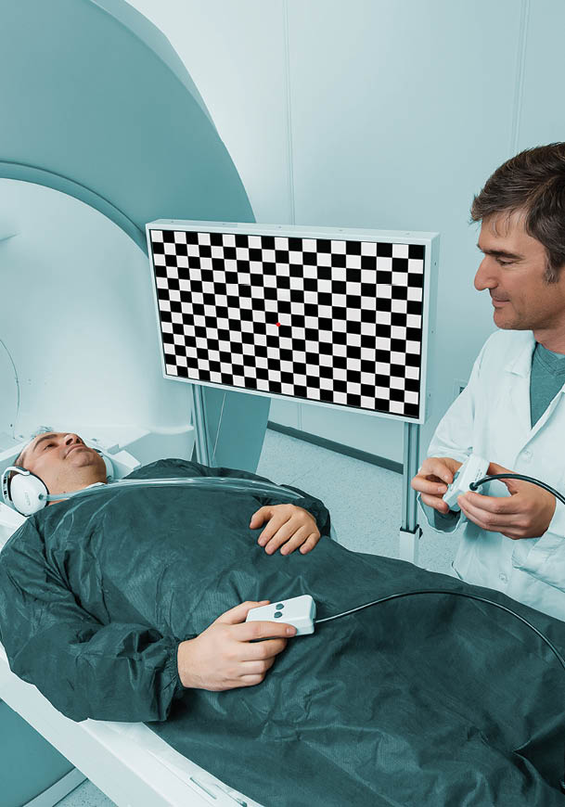

FMRI Hardware
Our hardware portfolio consists of equipment designed for functional magnetic resonance imaging. We offer a complete hardware package for clinical fMRI and a modular solution for research purposes. Our hardware is compatible with MRI scanners from all major vendors and uses standardised interface adapters for audio and visual input.

Our fMRI hardware system is designed, developed and manufactured under certified ISO 13485 and ISO 9001 Quality Management system. Our products intended for clinical use meet regulatory and safety requirements and have respective market clearances. Our highly competent and experienced specialists can provide guidance, helping customers to choose professional solutions tailor-made to their needs.
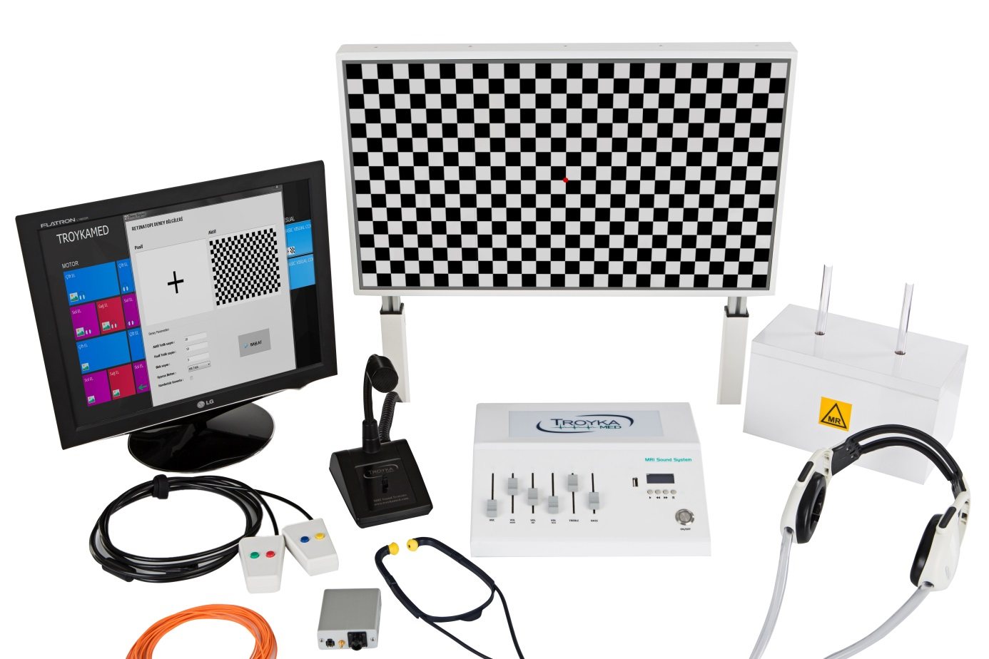

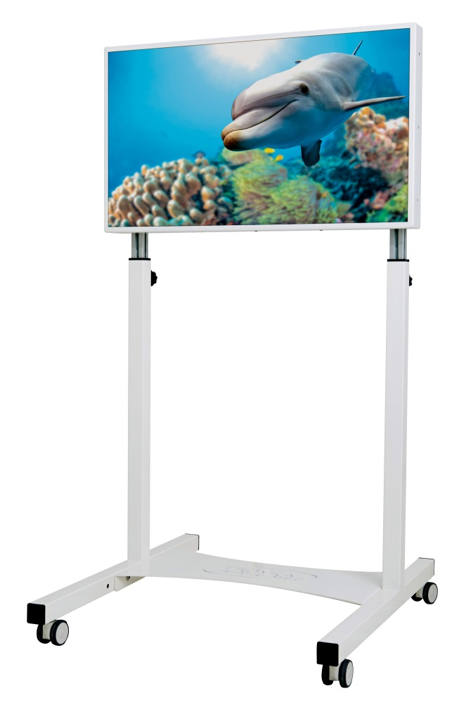
MRI LED Monitor
For fMRI, Patint comfort and instant feedback
Multipurpose Usage
This brand new, stunning 32” HD MRI LED monitor was designed to provide an optimal MRI compatible monitor that satisfies the needs of both clinical and advanced scientific applications.
Optimal Design
With its slim design, high definition display and
superior image quality, the InroomViewingDevice is an optimal choice for an easy to use alternative to conventional projectors or goggle based image
delivery systems. The innovative, front-facing camera provides an uninterrupted patient surveillance during examination. Thanks to the built-in USB hub, connecting patient communication and interface device is now extermely easy.
Flexible Positioning
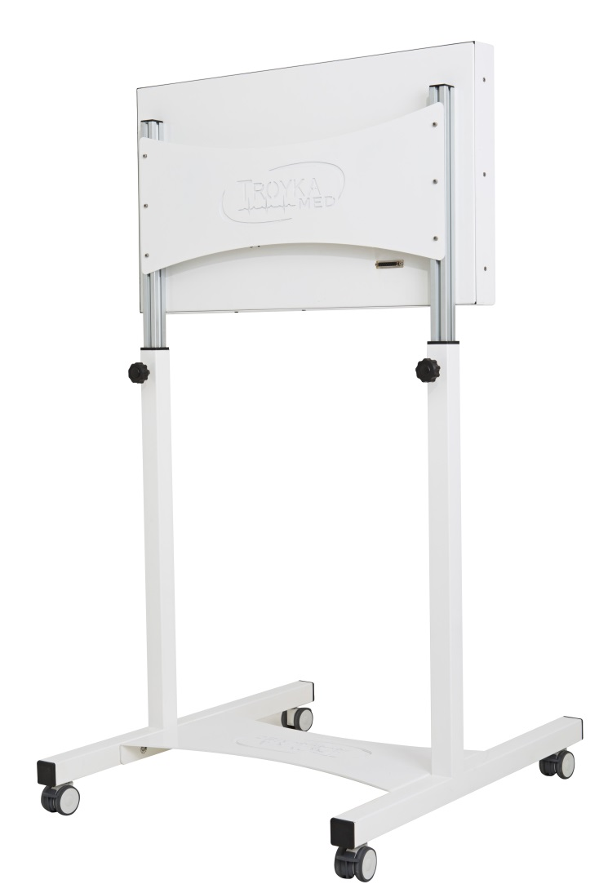
The low weight and height adjustable mobile foot stand allows easy positioning of the monitor anywhere in the MRI room. The monitor can also be ceiling mounted (through 3rd party).

Instant Feedback
The monitor facilitates the examination process by allowing the operating personnel to remain inside the examination room during procedures, thus allowing uninterrupted patient care and quick response time, which significantly improves clinical workflow.
MRI Audio System
State-of-the-art Properties
The headphones give a superb sound, replicating even minute details with incredible precision, thanks to the electrostatic transducers. The device significantly reduces scanner noise, allowing undisturbed patient communication during stimuli presentation.
Slim Headphones
The slim headphone, which is approximately 20 mm wide fit perfectly even in a 32-channel headcoil. The headphone provides aproximatly 29 dB noise isolation.

Designed for fMRI - Suited for Clinical Use
Designed specifically for fMRI, the superior sound quality and increased noise isolation provides a more precise audio stimulation to the patient, which yields a more robust BOLD response than traditional. Designed with reliability and durability in mind, the headphones are incredibly robust and suited for daily use in a busy clinical environment.

Communication Console
Through easy and accessible controls, the Communication Console offers one-way patient communication and full flexibility of audio settings. Thanks to its two input channels, it allows to connect a wide variety of audio devices through 3,5 mm mini jack. Üzerinde bulunan MP3 medya playerı sayesinde hastalara kolaylıkla USB den MP3 çalma ve müziği kontrol etme imanı sağlamaktadır. Üzerinde bulunan iki adet hoparlör sayesinde hastaya iletilen oudio komutların ve müziğin taknisyen tarafından duyulmasına imkan sağlamaktadır. Ayrıca içinde bulunan özel devre saysinde hastaya iletilen müzik ile Teknik odada bulunan müziğin ses seviyeleri birbirinden bağımsın olarak ayarlanabilmektedir. İçinde bulunan müte devresi sayesinde mikfonun bas konuş tuşuna basıldığı anda müziği otomarik olarak kesmekte ve düğme bırakıldığı anda müzik kaldığı yerden devam etmektedir. Arzu edildiği takdirde MR cihazının oudio komutları amfiye bağlanabilmekte ve bu sayede MR cihazından bir outovoise komutu geldiği anda müzik durdurularak autovoise komutu hastanın kulaklığına iletilmekte ve komut tamamlandıktan sonra müzik kaldığı yerden devam ettirilmektedir.
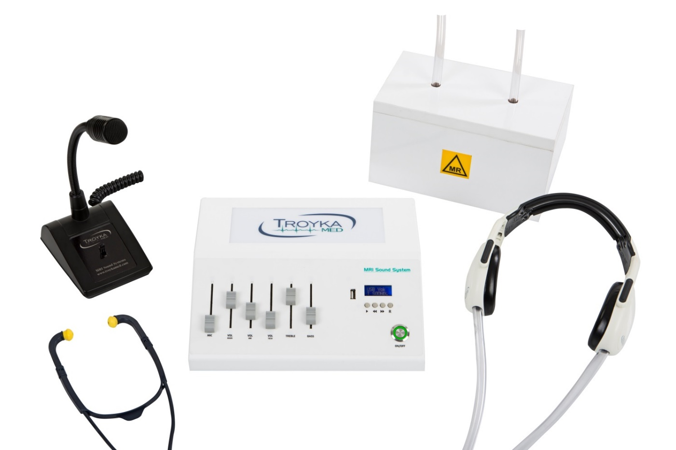
Fiberoptic Response Grip
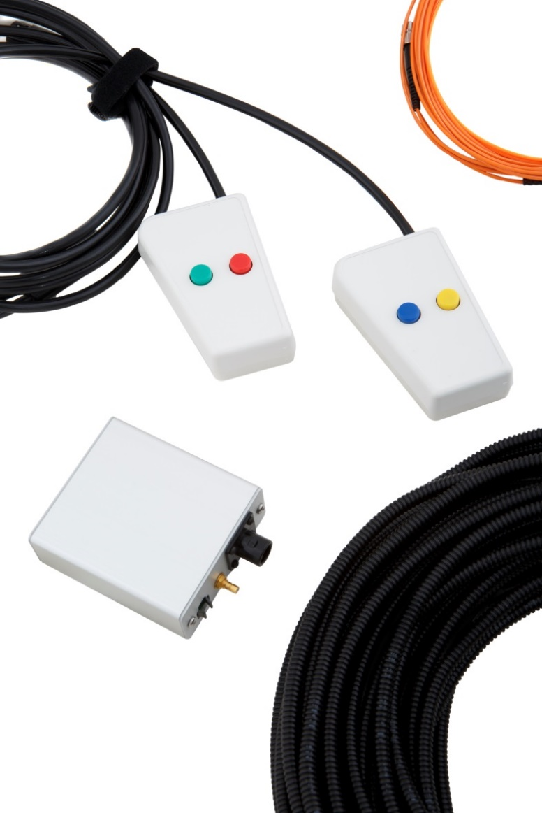
A unique patient response device
Fiberoptic Response Grip
Developed for Clinical and Research Use the Response Grip is an MRI compatible subject response device developed for both clinical and research users. Ergonomically designed for use in either hand and for minimizing patient movement inside the scanner, it is suitable for a wide range of experimental paradigms. We offer a large verity of response grips spatially for your requirements.

Compatible
The ResponseGrip is compatible with all leading stimulus presentation software packages, and interfaces with a number of third-party hardware devices.
Interface Unit
The Response Grip is 100% fiber optic and connects to the Interface Unit in the operator room through an available waveguide. The Interface Unit provides real-time feedback of subject responses via USB connection for PC.
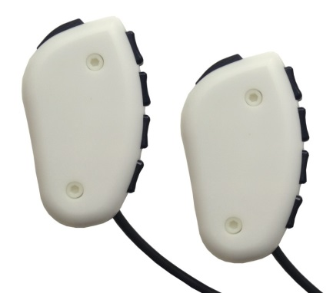
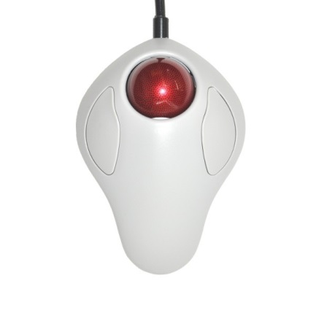
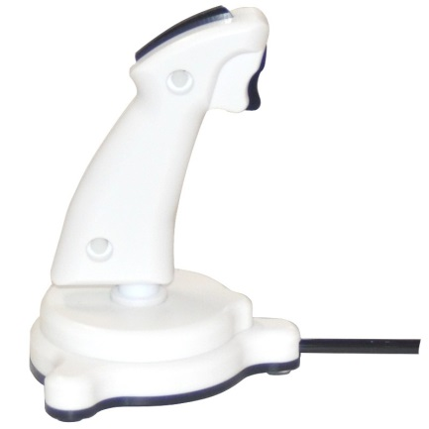

SyncBox
Simple solution for accurate control over stimulus presentation
The Synchronization Unit
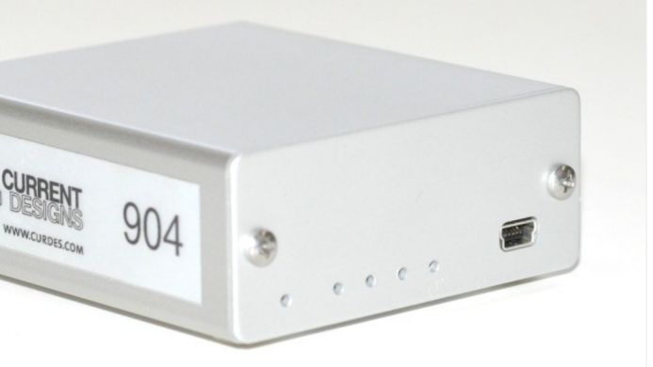
The Interface Unit provides real-time feedback of subject responses via USB connection for PC. The the syncbox is high feature package for subject response in fMRI. It's really easy to use. Attach the handheld to the interface and the computer USB cable and it is ready to get responses. There are two trigger inputs (optical and TTL) for syncing your computer with the scanner. It is designed to be used with all
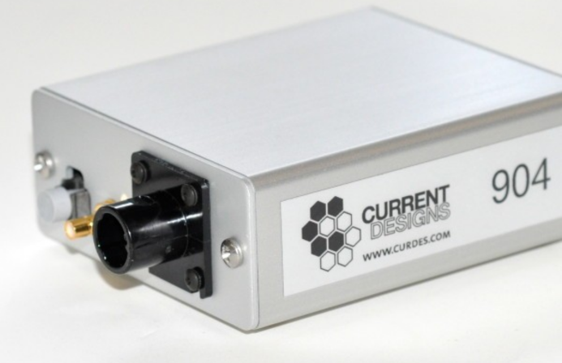
The Response Grip is 100% fiber optic, and connects to the Interface Unit in the operator room through an available waveguide. The Interface Unit provides real-time feedback of subject responses via USB connection for PC.

Clinical FMRI Activation Software
Stimulus presentation and workflow software
Easy stimulus generation and image acquisition
Ready-to-use standard clinical paradigm library
By using our FMRI clinical activation software a single technician can handle stimulus generation and image acquisition at the same time. It offers a choice of using pre-defined paradigms, modifying them based on user preferences.



